Paradise in Himalayas
09 Nights / 10 Days | 2N Delhi - 2N Shimla – 3N Manali – 1N Chandigarh – 1N Delhi

PACKAGE HIGHLIGHTS:
- Visit in Delhi – Jama Masjid, Qutub Minar, Humayun Tomb
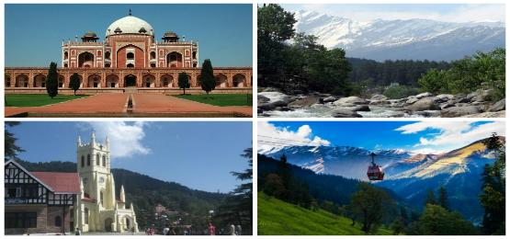
- Drive past in Delhi - Red Fort, Rajghat, President House
- Rickshaw ride in Chandni Chowk
- Excursion to Kufri, Mall road and scandal point in Shimla
- Solang Valley, Hadimba Temple, Mall road and much more... in Manali
- In Chandigarh, visit Nek Chand’s popular Rock Garden, made out of scrap and waste materials
- Services of English-speaking guide during sightseeing tours
- Assistance at airport and sightseeing tours by private air-conditioned vehicle
- Start and End in Delhi

HOTELS OFFERED:

City | Nights | 5* Hotel | 4* Hotel | 3* Hotel | Meal Plan
Delhi | 3 | Crowne Plaza MV | SK Premium Park | Surya International | Breakfast
Shimla | 2 | East Bourne Resort & Spa | Snow Valley Resort | Bridge View Regency | Breakfast & Dinner
Manali | 3 | Citrus Manali Resorts | Manali Heights | Victory Resort | Breakfast & Dinner
Chandigarh | 1 | Hyatt Regency | Hotel 6 | Sun Park Resort | Breakfast

PACKAGE COST IN EUR | 5* Hotel | 4* Hotel | 3* Hotel
Cost Per Person when 2 Pax Travelling | EUR 673 | EUR 484 | EUR 412
Cost Per Person when 3 Pax Travelling | EUR 578 | EUR 418 | EUR 359
Cost Per Person when 4 Pax Travelling | EUR 580 | EUR 392 | EUR 322
Cost for Child with Bed (Hotel Cost only) | EUR 262 | EUR 154 | EUR 141
Cost for Child without Bed (Hotel Cost only) | EUR 127 | EUR 115 | EUR 104

PACKAGE INCLUSIONS | PACAKAGE EXCLUSIONS
- 9 night accommodation in well-appointed rooms as mentioned below hotels or equivalent  - Assistance at the airport  - Services of English-speaking guide during sightseeing tours  - Sightseeing as per itinerary by private tourist vehicle  - Drivers allowances, toll taxes and Govt. Service Tax | - Air tickets and airport taxes  - Entry Fee at the Monuments  - Sightseeing of Rohtang Pass  - Optional activities are subject to availability. Charges additional  - Items of personal nature like laundry, phone calls, tips to guides / drivers etc.  - Camera / Video camera fees applicable at monuments

NOTES:
Shimla & Kangra State Museums /vice regal lodge & Roerich Art Gallery/Naggar remain closed on Mondays
All Govt. Holidays, Zoo in Kufri also remains closed on Mondays
Hotel Check in 1400hrs and check out 1200hrs
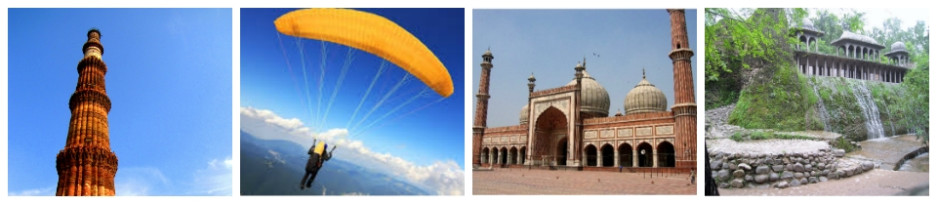
Package cost will not be valid from 20th December 2018 – 10th January 2019. Also on public holidays, festivals, exhibitions and long-weekends. A surcharge will be levied and will be advised at the time of booking
This package is valid from 01st October’18 till 31st March’19 (Except from 20th December’18 – 10th January’19)

