Golden Triangle
05 Nights / 06 Days | 2N Delhi – 1N Agra – 2N Jaipur

PACKAGE HIGHLIGHTS:
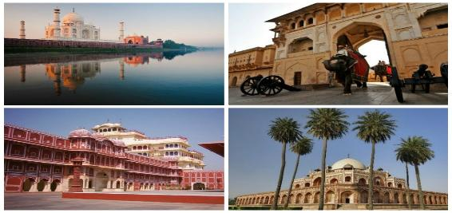

- Visit in Delhi – Jama Masjid, Qutub Minar, Humayun Tomb
- Drive past in Delhi - Red Fort, Rajghat, President House & India Gate
- Rickshaw ride in Chandni Chowk
- Visit in Agra – Taj Mahal, Agra Fort & Fateh-pur Sikri
- Visit in Jaipur – Amber Fort, City Palace, Jantar Mantar Observatory, Hawa Mahal & Albert Museum
- Elephant ride at Amber Fort
- Services of English-speaking guide during sightseeing tours
- Assistance at airport and sightseeing tours by private air-conditioned vehicle
- Start and End in Delhi

HOTELS OFFERED:

City | Nights | 5* Hotel | 4* Hotel | 3* Hotel | Meal Plan
Delhi | 2 | Crowne Plaza MV | SK Premium Park | Surya International | Breakfast
Agra | 1 | Crystal Sarovar Premiere | Howard Plaza - The Fern | Taj Vilas | Breakfast
Jaipur | 2 | Holiday Inn City Centre | Park Regis | Leisure Inn Grand Chanakya | Breakfast

PACKAGE COST IN EUR | 5* Hotel | 4* Hotel | 3* Hotel
Cost Per Person when 2 Pax Travelling | EUR 439 | EUR 330 | EUR 303
Cost Per Person when 3 Pax Travelling | EUR 360 | EUR 272 | EUR 253
Cost Per Person when 4 Pax Travelling | EUR 356 | EUR 247 | EUR 222
Cost for Child with Bed (Hotel Cost only) | EUR 113 | EUR 71 | EUR 67
Cost for Child without Bed (Hotel Cost only) | EUR 50 | EUR 36 | EUR 36

PACKAGE INCLUSIONS | PACAKAGE EXCLUSIONS
- 5 night accommodation in well-appointed rooms as mentioned in above hotels or equivalent  - Assistance at the airport & Hotel check-in / check-out  - Cycle-rickshaw ride at Chandni Chowk  - Elephant ride at Amber Fort  - Services of English-speaking guide during sightseeing tours as per the itinerary  - Sightseeing as per itinerary by private tourist vehicle  - Drivers allowances, toll taxes and Govt. Service Tax | - Air tickets and airport taxes  - Optional activities are subject to availability. Charges additional.  - Entry Fee at the Monuments  - Items of personal nature like laundry, phone calls, tips to  Guides / drivers etc.  - Camera / Video camera fees applicable at monuments

NOTES:
Monuments Closed On
Agra - Taj Mahal on every Friday
Jaipur – Elephant ride at Amber Fort will not be operational during Eid /Navrataras Festivals
Hotel Check in 1400hrs and check out 1200hrs
Package cost will not be valid from 20th December 2018 – 10th January 2019. Also on public holidays, festivals, exhibitions and long-weekends. A surcharge will be levied and will be advised at the time of booking
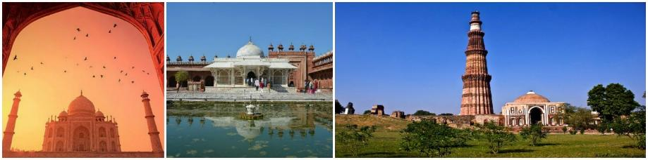
This package is valid from 01st October’18 till 31st March’19 (Except from 20th December’18 – 10th January’19)

