God's Own Country
06 Nights / 07 Days | 1N Cochin – 2N Munnar – 1N Alleppey HB – 2N Kumarakom

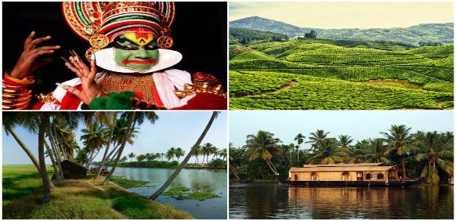
PACKAGE HIGHLIGHTS:
- In Cochin, Kathakali Dance, Mattanchery palace & Jewish Synagogue
- Trip to Eravikulam National Park, Mattupetty Dam, Tea Plantation & Museum, Munnar
- Cruise through beautiful Kerela backwaters and stay on Houseboat, Alleppey
- Visit - Kumarakom Bird Sanctuary
- Services of English-speaking guide during sightseeing tours
- Assistance at airport and sightseeing tours by private air-conditioned vehicle
- Start in Cochin and End in Cochin

HOTELS OFFERED:

City | Nights | 5* Hotel | 4* Hotel | 3* Hotel | Meal Plan
Cochin | 1 | Le Meridien | Radisson Blu | Cochin Palace | Breakfast
Munnar | 2 | Mountain Club | Tea County KTDC | Grand Plaza | Breakfast
Alleppey HB | 1 | Lakes & Lagoons Premium | Lakes Lagoons Deluxe | Casablanca | 3 Major Meals
Kumarakom | 2 | Zuri Kumarakom Kerala Resort & Spa | Eastend Lake Song | Manor Backwater Resort | Breakfast

PACKAGE COST IN EUR | 5* Hotel | 4* Hotel | 3* Hotel
Cost Per Person when 2 Pax Travelling | EUR 598 | EUR 421 | EUR 325
Cost Per Person when 3 Pax Travelling | EUR 486 | EUR 343 | EUR 255
Cost Per Person when 4 Pax Travelling | EUR 540 | EUR 361 | EUR 266
Cost for Child with Bed (Hotel Cost only) | EUR 171 | EUR 136 | EUR 91
Cost for Child without Bed (Hotel Cost only) | EUR 92 | EUR 61 | EUR 47

PACKAGE INCLUSIONS | PACAKAGE EXCLUSIONS
- 6 night accommodation in well-appointed rooms as mentioned above hotels or equivalent  - Services of English-speaking guide during sightseeing tours in Cochin & Munnar  - Assistance at the airport  - Sightseeing as per itinerary by private tourist vehicle  - Drivers allowances, toll taxes and Govt. Service Tax | - Air tickets and airport taxes  - Entry Fee at the Monuments  - Kathakali Show in Cochin  - Items of personal nature like laundry, phone calls,  tips to guides / drivers etc.  - Camera / Video camera fees applicable at monuments

NOTES:
Monument Closed On
Cochin - Jewish Synagogue will be closed on Friday/Saturday/Jewish Holidays
Cochin - Mattanchery Palace will be closed on Friday
Munnar - Eravikulam National Park will be closed in the month of February & March
Munnar - Tata Tea Museum will be closed on Monday
Hotel Check in 1400hrs and check out 1200hrs
Package cost will not be valid from 20th December 2018 – 10th January 2019. Also on public holidays, festivals, exhibitions and long-weekends. A surcharge will be levied and will be advised at the time of booking.
This package is valid from 01st October’18 till 31st March’19 (Except from 20th December’18 – 10th January’19)

