Temple Tour of South with Kovalam
10 Nights / 11 Days | 2N Chennai– 1N Mahabalipuram– 1N Pondicherry - 1N Tanjore – 2N Madurai–1N Kanyakumari– 2N Kovalam

PACKAGE HIGHLIGHTS:
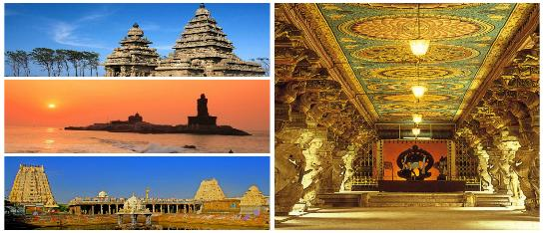
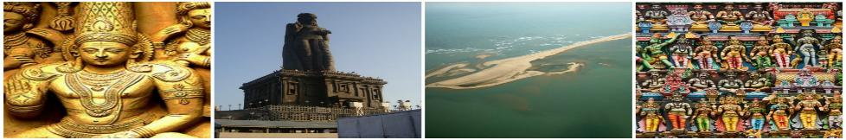
- Visit in Chennai – Fort St George, St. Mary's Church, Kapaleeshwarar Temple, San Thome Cathedral, Government State Museum & National Art Gallery
- 2nd longest beach in world – Marina Beach
- Panch Rathas, Arjuna's Penance and the Shore Temple in Mahabalipuram
- In Tanjore, visit Brihadeshwara Temple, Tanjore Palace & Museum
- In Pondicherry, visit cover beaches, Aurobindo ashram, Museum, churches and Auroville.
- Enroute in Trichy cover Rock Fort, Srirangam and Thiruvanaikkaval
- In Madurai, visit Meenakshi Temple, Gandhi Memorial Museum, Tirumalai Nayak and Koodal Azhagar Temple
- Visit Kanyakumari - Vivekananda Rock, Gandhi Museum and Kumari Amman Temple
- Kovalam beaches, Napier Museum, Art Gallery & Kuthiramalika Palace
- Services of English-speaking guide during sightseeing tours
- Assistance at airport and sightseeing tours by private air-conditioned vehicle
- Start From Chennai and End in Trivandrum

HOTELS OFFERED:

City | Nights | 5* Hotel | 4* Hotel | 3* Hotel | Meal Plan
Chennai | 2 | Crowne Plaza  Chennai Adyar Park | Savera Hotel | The Lotus Hotel Sameera | Breakfast
Mahabalipuram | 1 | Radisson Resort Temple Bay | The Grande Bay Resort | Sea Breeze | Breakfast
Pondicherry | 1 | Le Pondy | Accord Puducherry | Atithi | Breakfast
Tanjore | 1 | Svatma Hotel | Sangam Hotel | Star Residency | Breakfast
Madurai | 2 | Heritage Madurai | Astoria | Star Residency | Breakfast
Kanyakumari | 1 | Sparsa Resort | Sparsa Resort | Sparsa Resort | Breakfast
Kovalam | 2 | Turtle on the Beach | Travancore Heritage | Abad Harmonia  Ayurveda Beach Garden | Breakfast

PACKAGE COST IN EUR | 5* Hotel | 4* Hotel | 3* Hotel
Cost Per Person when 2 Pax Travelling | EUR 1043 | EUR 822 | EUR 691
Cost Per Person when 3 Pax Travelling | EUR 829 | EUR 640 | EUR 542
Cost Per Person when 4 Pax Travelling | EUR 845 | EUR 624 | EUR 493
Cost for Child with Bed (Hotel Cost only) | EUR 271 | EUR 179 | EUR 153
Cost for Child without Bed (Hotel Cost only) | EUR 149 | EUR 100 | EUR 105

PACKAGE INCLUSIONS | PACAKAGE EXCLUSIONS
- 10 night accommodation in well-appointed rooms as mentioned above hotels or equivalent  - Assistance at the airport  - Services of English-speaking guide during sightseeing tours  - Sightseeing as per itinerary by private tourist vehicle  - Drivers allowances, toll taxes and Govt. Service Tax | - Air tickets and airport taxes  - Entry Fee at the Monuments / Temples  - Items of personal nature like laundry, phone calls, tips to guides / drivers etc.  - Camera / Video camera fees applicable at monuments

NOTES:
Monument Closed on
Chennai – Govt. Museum & St. George Church will remain closed on every Friday
Madurai – Gandhi Museum will remain closed on every Monday
Trivandrum - Padmanabhaswamy Temple – Non-Indians are not allowed. Dress code to enter at the temple is Dhoti for Men & Saree for Women.
Hotel Check in 1400hrs and check out 1200hrs
Package cost will not be valid from 20th December 2018 – 10th January 2019. Also on public holidays, festivals, exhibitions and long-weekends. A surcharge will be levied and will be advised at the time of booking

This package is valid from 01st October’18 till 31st March’19 (Except from 20th December’18 – 10th January’19)

