Golden Triangle With Charismatic Kashmir
10 NIGHTS / 11 DAYS | 1N DELHI - 1N SRINAGAR HB - 2N SRINAGAR - 2N DELHI – 1N AGRA- 2N JAIPUR – 1N DELHI

PACKAGE HIGHLIGHTS:
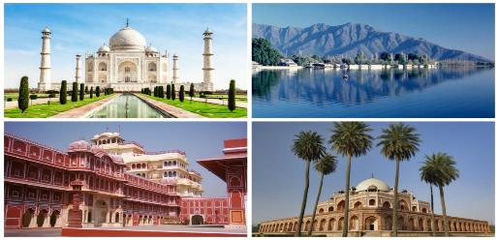
- Visit in Delhi – Jama Masjid, Qutub Minar, Humayun Tomb
- Drive past in Delhi - Red Fort, Rajghat, President House & India Gate
- Rickshaw ride in Chandni Chowk
- Visit in Agra – Taj Mahal, Agra Fort & Fateh-pur Sikri
- Visit in Jaipur – Amber Fort, City Palace, Jantar Mantar Observatory, Hawa Mahal & Albert Museum
- Elephant ride at Amber Fort
- In Pahalgam, visit Aru valley, Betab valley and chandanwari (start point of Amarnath-yatra)
- In Gulmarg, enjoy Gandola Ride
- In Srinagar, enjoy Shikara Ride at Dal lake
- Assistance at airport and sightseeing tours by private air-conditioned vehicle
- Start and End in Delhi

HOTELS OFFERED:

CITY | NIGHTS | 5* Hotel | 4* Hotel | 3* Hotel | MEAL PLAN
Delhi | 4 | Crowne Plaza MV | SK Premium Park | Surya International | Breakfast
Srinagar HB | 1 | Meena Luxury Houseboat  Club Room | Meena Luxury Houseboat  Club Room | Meena Standard Houseboat | Breakfast & Dinner
Srinagar | 2 | Hotel Lemon Tree  Heritage by Heevan | Pine Spring | Jamal Resort | Breakfast & Dinner
Agra | 1 | Crystal Sarovar Premiere | Howard Plaza - The Fern | Taj Vilas | Breakfast
Jaipur | 2 | Holiday Inn City Centre | Park Regis | Leisure Inn Grand Chanakya | Breakfast

PACKAGE COST IN EUR | 5* Hotel | 4* Hotel | 3* Hotel
Cost Per Person when 2 Pax Travelling | EUR 789 | EUR 599 | EUR 514
Cost Per Person when 3 Pax Travelling | EUR 650 | EUR 496 | EUR 437
Cost Per Person when 4 Pax Travelling | EUR 666 | EUR 475 | EUR 391
Cost for Child with Bed (Hotel Cost only) | EUR 239 | EUR 176 | EUR 144
Cost for Child without Bed (Hotel Cost only) | EUR 114 | EUR 93 | EUR 90

PACKAGE INCLUSIONS | PACAKAGE EXCLUSIONS
- 10 night accommodation in well-appointed rooms as mentioned below hotels or equivalent  - Assistance at the airport & Hotel check-in / check-out  - Services of English-speaking guide during sightseeing tours except Kashmir  - Sightseeing as per itinerary by private tourist vehicle  - Rickshaw ride in Chandni Chowk  - Elephant / Jeep ride at Amber Fort  - 1 session of Shikara-ride  - Drivers allowances, toll taxes and Govt. Service Tax | - Air tickets and airport taxes  - Entry Fee at the Monuments  - Gandola Ride  - Items of personal nature like laundry, phone calls, tips to guides / drivers etc.  - Camera / Video camera fees applicable at monuments

NOTES:
Monuments Closed On
Agra - Taj Mahal on every Friday
Jaipur – Elephant ride at Amber Fort will not be operational during Eid /Navrataras Festivals
Issued Boarding Passes for Gandola ride in Gulmarg are valid for the period of 03 Hours only, Visitors boarding between Gulmarg to Kungdoori (Phase 1) from 1400 Hrs. to 1600 Hrs. can stay at G2 Station till 1700 HRS Only and Visitors boarding between Kungdoori (Phase 1) to Apparwath (Phase 2) from 1400 Hrs. to 1500 Hrs. can stay at Apparwath
Hotel Check in 1400hrs and check out 1200hrs
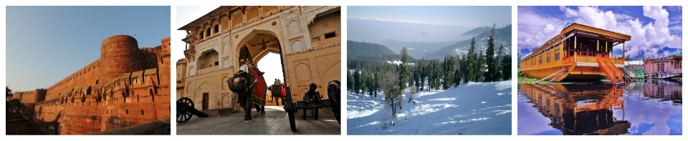
Package cost will not be valid from 20th December 2018 – 10th January 2019. Also on public holidays, festivals, exhibitions and long-weekends. A surcharge will be levied and will be advised at the time of booking.
Package is valid from 01st October’18 till 31st March’19 (except from 20th December’18 – 10th January’19)

